NoSQL Performance Benchmarking
Srinivasa Gorijavolu, Michael Mzyk, Satish Patharkar

Abstract— Our project team evaluated the performance of two of the most relevant NoSQL Open Source databases, Cassandra and MongoDB, in the context of a fictitious Big Data case study. Various read/write queries were used to conduct benchmarking studies in both single-node and multi-node cluster environments, and performance statistics were derived and interpreted in the context of Amdahl´s Law.

Index Terms— Amdahl´s Law, Benchmarking, Cassandra, NoSQL, Open Source, MongoDB

Introduction

This document presents the final version of our project report for the 2016 Projects on Big Data Software class. It outlines description, problem statement and purpose of the project and walks the reader through its implementation and interpretation.

Project description

As already stated in our Project proposal document, we have installed, configured and populated MongoDB and evaluated their performance under different query types (but same load conditions) in the context of the following environments:
• Single node
• multiple nodes (with n = 4)
Please note that we finally decided to leave the Spark technology out of the scope of this benchmarking study in favor of a higher level of insight regarding benchmarking results, including (but not limited to) their interpretation in the context of Amdahl´s law.

Problem statement

The startup company “Light and love” runs an online dating website designed specifically to bring together single men and women for long-term relationships. Its IT department wants to decide whether to run their noSQL databases in a standalone or in a 4-node multicluster environment, and asks our team of highly motivated IU Data Science students to elaborate and evaluate a performance benchmarking study.
This benchmarking study will be based on a sample of the most important dataset (resp. most important “asset”) of the company: its “user” dataset in JSON file format with the following characteristics:
- Around 10 mio individual user records are contained in the dataset
- Data volume is 4.2 GB (sample size)
- Data is modeled as “flat file” containing all important user records, and one record of the dataset would look like this:

{ "_id" : 56076262, "UserID" : 56076262, "UserStatus" : "Active", "UserStartDate" : "2014-02-11", "Gender" : "Male", "BirthDate" : "1959-08-25", "EducationName" : "unknown", "AssetName" : "ehc016", "CampaignDescription" : "unknown", "SegmentName" : "Default Segment", "GenderPreference" : "Female", "IncomeLevelName" : "$40000 to $60000", "UserNumberofMarriages" : 2, "UserChildren" : 3, "UserSmoke" : "2", "Promotion" : "unknown", "PPR" : "Basic PPR", "LocaleSite" : ".AU", "TransactionAmount" : 311.4, "City" : "Hillston", "ZipCode" : "2675", "State" : "New South Wales", "country" : "Australia " }

Please note that although this problem is fictitious, it is based on an (anonymized) real dataset of the online dating company “E-Harmony” LINK

Purpose and objectives

The purpose of this project is to gain insights on the effects of parallelization on the performance of two of the most important Open Source noSQL databases: MongoDB and Cassandra.

Main objectives of the project are:
- Get familiar with the installation and configuration of noSQL databases and, in particular, with their setup as multimode cluster environments
- Learn how to successfully write queries of different types in both MongoDB and Cassandra
- Evaluate and compare the performance of different query types based on different performance KPIs and benchmarking methods
- Interpret all obtained results in the context of Amdahl´s law

Implementation

For realizing our performance benchmarking studies on both MongoDB and Cassandra, the following high-level steps have been implemented:

1.) Installation of MongoDB
We installed MongoDB on four nodes in the following ways:
- “manually” on a command-by-command basis
- “automatically” based on Ansible roles

2.) Configuration of MongoDB
We configured MongoDB on four nodes by following these steps:
- We created three instances of mongod processes on each node, thus creating four different “three-node-Replicasets”
- We created four MongoDB sharding cluster
- We created and enabled a shardDB database for sharding
- We imported the dataset and populated two collections called ehuser and ehuserShard.
- Please refer to the following code snippet for a summary of all four created sharding cluster:

mongos> db.ehuserShard.getShardDistribution()
...
Totals
data : 4.6GiB docs : 9053358 chunks : 43
Shard replicaSet1 contains 37.27% data, 37.27% docs in cluster, avg obj size on shard : 546B
Shard replicaSet2 contains 23.97% data, 23.97% docs in cluster, avg obj size on shard : 546B
Shard replicaSet3 contains 21% data, 21% docs in cluster, avg obj size on shard
Shard replicaSet4 contains 17.73% data, 17.73% docs in cluster, avg obj size on shard : 546B

3.) Query MongoDB

The following queries have been executed as JavaScript files against the database (execution results will be provided in the following chapter):

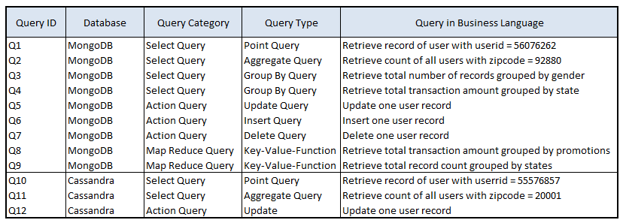
Table 1: MongoDB Query Overview

4.) Installation of Cassandraby
We installed Datastax Enterprise Cassandra as both standalone and four-node environments in a manual way, i.e. on a command-to-command basis

5.) Configuration of Cassandra
We configured Cassandra on both stand-alone and multi-node cluster by following these steps:
- Connect to stand-alone resp. multi-node cluster and create key spaces

- Create table called ehuser within eh tablespace
-Create Index on ehuser table zipcode

6.) Query Cassandra

The following queries have been executed in SQL format against the database (execution results will be provided in the following chapter):

Table 2: Cassandra Query Overview

Results

speedup S = T₁/T₄

Variable definitions:

- T₁ is the execution time taken in the standalone cluster, also called “serial execution time”
- T₄ is the execution time taken in the fournode cluster, also called “parallel execution time”

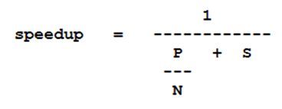

Variable definitions:

- P is the parallel portion of work
- S is the serial portion of work
- N is the number of processors (in our case: number of cores)
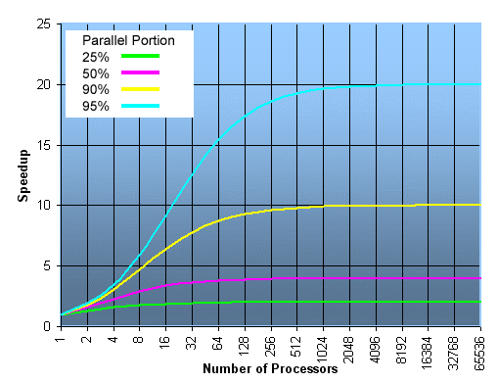
Figure 2: Number of Processors vs. Speedup in Amdahl´s Law

Findings

Acknowledgements
Special thanks go to our teacher Judy Qui, assistant professor of Computer Science at Indiana University, for providing us with broad and at the same time deep knowledge in the field of Cloud Computing for Data Intensive Sciences, and for inspiring and motivating us to work hard on both our theoretical understanding and practical programming skills.
We also would like to thank our teacher and advisor Saliya Ekanayake, research assistant at Indiana University, for his guidance and great availability to help with all project- and programming-related tasks whenever required.

References
Brin, S., & Page, Lawrence (1998). The anatomy of a large-scale hypertextual web search engine. Comput. Networks and ISDN Systems 30, pp. 107-117.
Chang, F., Dean, J., Ghemawat, S. et al. (2006). Bigtable: A Distributed Storage System for Structured Data. Proc. OSDI'06: Seventh Symposium on Operating System Design and Implementation, Seattle, WA.
Ghemawat, S., Gobioff, H., & Leung, Shun-Tak (2003). The Google file system. Proc. 19th ACM Symp. on Operating System Principles, pp. 29-43.
Gunarathne, T. (2015). Hadoop MapReduce v2 Cookbook, Second Edition. Birmingham, UK: Packt Publishing.
Hwang, K., Fox, G.C., & Dongarra, J. J. (2012). Distributed and Cloud Computing. Waltham, MA: Morgan Kaufmann.
Kumar, D., Kumar, A. (2013). Design Issues for Search Engines and Web Crawlers: A Review. IOSR Journal of Computer Engineering (IOSR-JCE) Volume 15, Issue 6, pp.34-37.
Miner, D., & Shook, A. (2015). MapReduce Design Patterns. Sebastopol, CA: O´Reilly Media, Inc.
White, T. (2015). Hadoop: The Definitive Guide, Forth Edition. Sebastopol, CA: O´Reilly Media, Inc.
PageRank (n.d.). In Wikipedia. Retrieved May 1, 2016, from https://en.wikipedia.org/wiki/PageRank

